
Instructions on accessing the MTEL Student Portal by students
The MTEL Student Portal is available in the new MTEL application for the 2nd semester. This portal allows students to manage certain elements of their cooperative education placement.
The MTEL Student Portal is Web based, it is accessible by:
- A school computer, a tablet or a smart phone
- The interface is responsive and will adjust automatically to the size and resolution of the screen.
To access the MTEL Student Portal, a student must:
- First login to the school environment, using his/her login credentials
- Once the student is recognized by the system, he/she can access the MTEL Student Portal
- The direct link to the MTEL Student Portal is: https://ucdsb-student.mtel.ca/ , this link may be accessible directly through a web browser or integrated in a Widget on a student interface.
- Once the student has access to the MTEL Student Portal, he/she will see a blue interface.
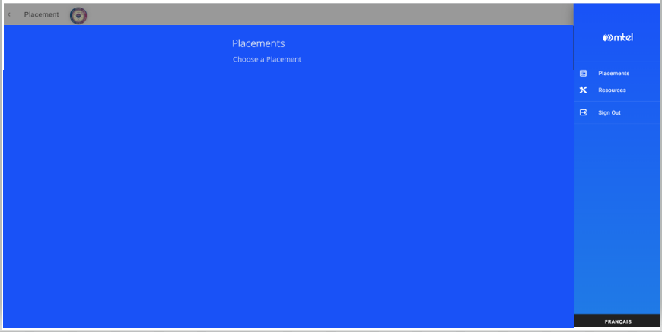
- If the student has an active placement, he/she will be able to access its placement information.
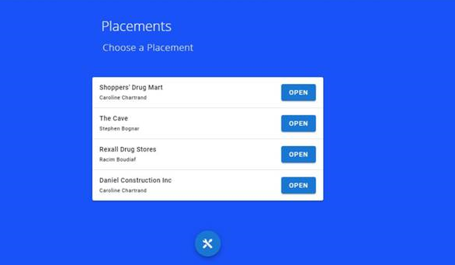
- The student is now ready to open a placement and manage its content.

Once a student ends his/her access to the MTEL Student Portal, he/she must use the sign-out button to exit the portal, shutdown the browser and logout of the computer before another student starts a new session.
